HTML Hyperlink Element

📘 Definition
# Source: AI Source: Provided by: [Data Path: Persons Table -> ID Column: 1, Name_En Column: Motasem Essam] -> From: [ChatGPT] on [5/6/2026]
The HTML <a> (anchor) element is used to create hyperlinks.
Hyperlinks allow users to:
- move between webpages
- open files
- navigate websites
- send emails
- jump to sections

🌐 Basic Hyperlink Example
# Source: AI Source: Provided by: [Data Path: Persons Table -> ID Column: 1, Name_En Column: Motasem Essam] -> From: [ChatGPT] on [5/6/2026]
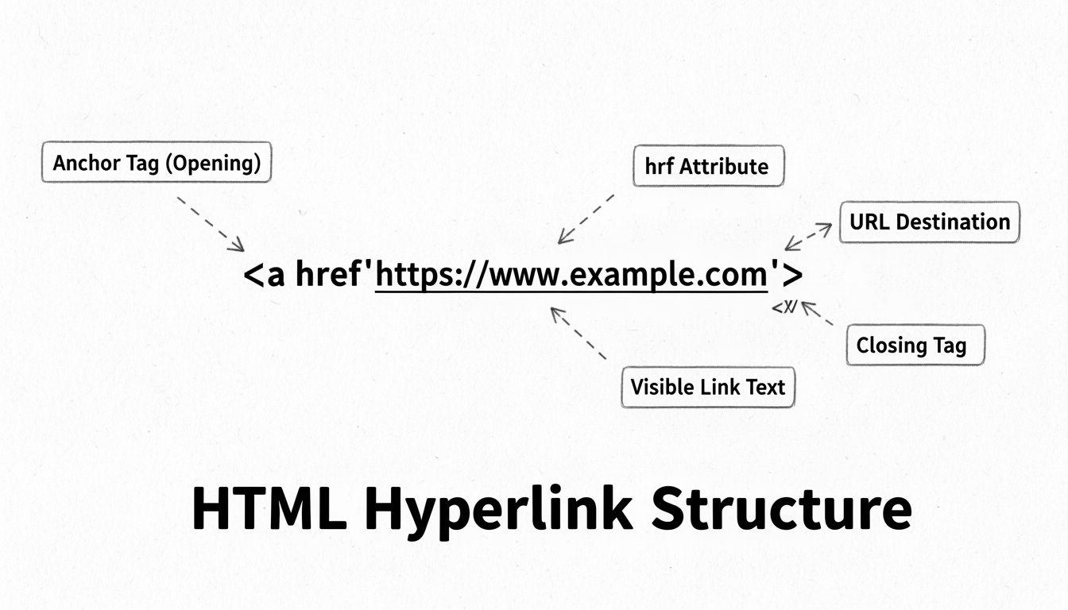
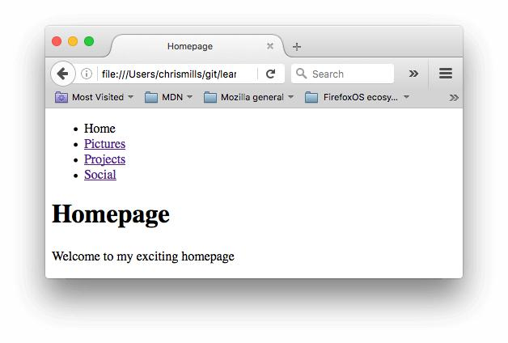
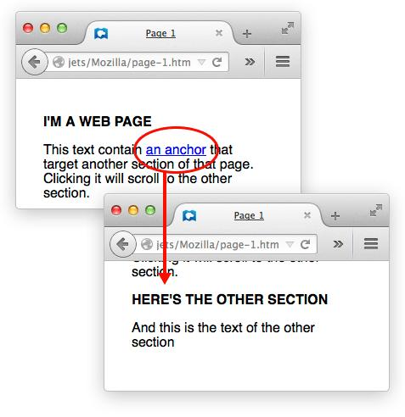
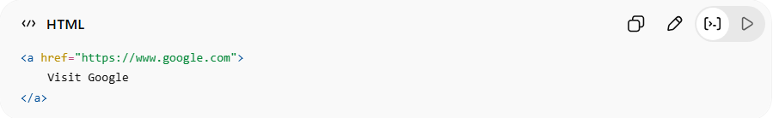
<a href="https://www.google.com">
Visit Google
</a>
👉 Clicking the link opens the webpage

🧠 Main Attributes of <a>
# Source: AI Source: Provided by: [Data Path: Persons Table -> ID Column: 1, Name_En Column: Motasem Essam] -> From: [ChatGPT] on [5/6/2026]
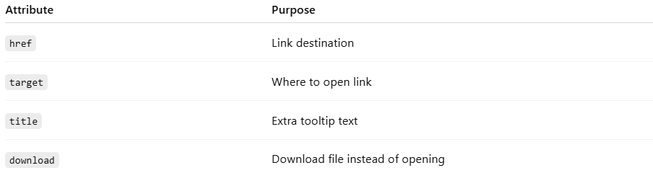
Attribute | Purpose
href | Link destination
target | Where to open link
title | Extra tooltip text
download | Download file instead of opening

🔤 Common Types of Hyperlinks

1. 🌍 External Link
# Source: AI Source: Provided by: [Data Path: Persons Table -> ID Column: 1, Name_En Column: Motasem Essam] -> From: [ChatGPT] on [5/6/2026]
📖 Description
Links to another website.
💻 Example:
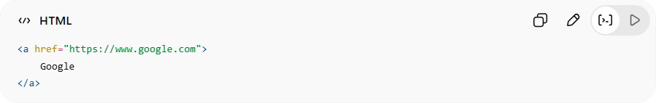
<a href="https://www.google.com">
Google
</a>

2. 📄 Internal Link
# Source: AI Source: Provided by: [Data Path: Persons Table -> ID Column: 1, Name_En Column: Motasem Essam] -> From: [ChatGPT] on [5/6/2026]
📖 Description
Links to another page inside the same website.
💻 Example:
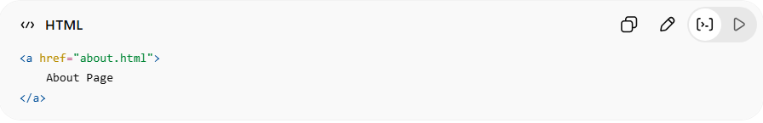
<a href="about.html">
About Page
</a>

3. 🎯 Bookmark/Section Link
# Source: AI Source: Provided by: [Data Path: Persons Table -> ID Column: 1, Name_En Column: Motasem Essam] -> From: [ChatGPT] on [5/6/2026]
📖 Description
Jumps to another section on the same page.
💻 Example:
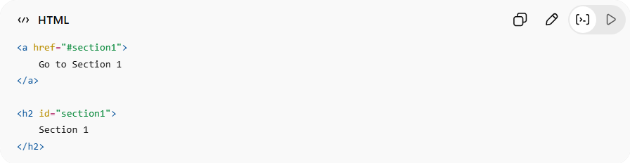
<a href="#section1">
Go to Section 1
</a>
<h2 id="section1">
Section 1
</h2>

4. 📧 Email Link
# Source: AI Source: Provided by: [Data Path: Persons Table -> ID Column: 1, Name_En Column: Motasem Essam] -> From: [ChatGPT] on [5/6/2026]
📖 Description
Opens email application.
💻 Example:
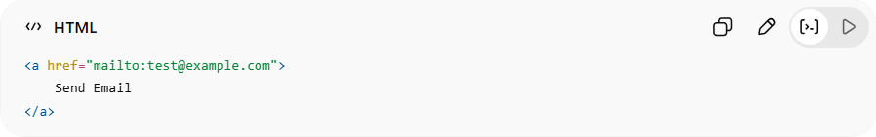
<a href="mailto:test@example.com">
Send Email
</a>

5. 📞 Phone Link
# Source: AI Source: Provided by: [Data Path: Persons Table -> ID Column: 1, Name_En Column: Motasem Essam] -> From: [ChatGPT] on [5/6/2026]
📖 Description
Opens phone dialer on mobile devices.
💻 Example:
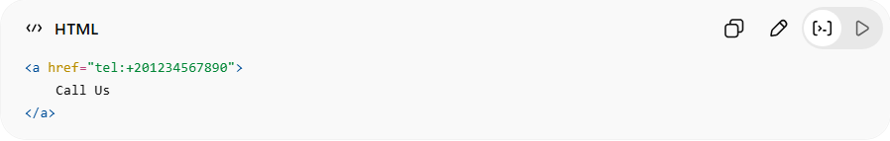
<a href="tel:+201234567890">
Call Us
</a>

6. 📥 Download Link
# Source: AI Source: Provided by: [Data Path: Persons Table -> ID Column: 1, Name_En Column: Motasem Essam] -> From: [ChatGPT] on [5/6/2026]
📖 Description
Downloads a file.
💻 Example:
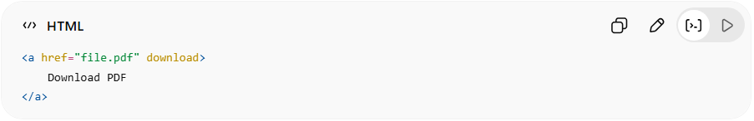
<a href="file.pdf" download>
Download PDF
</a>

7. 🪟 Open Link in New Tab
# Source: AI Source: Provided by: [Data Path: Persons Table -> ID Column: 1, Name_En Column: Motasem Essam] -> From: [ChatGPT] on [5/6/2026]
📖 Description
Uses target="_blank".
💻 Example:
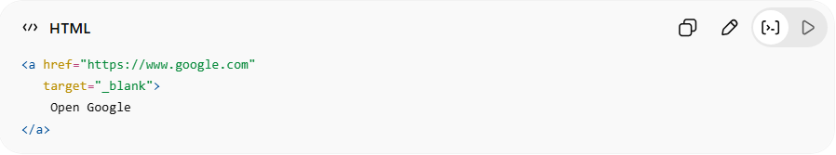
<a href="https://www.google.com"
target="_blank">
Open Google
</a>

8. 🖼️ Use Image as a Link
# Source: AI Source: Provided by: [Data Path: Persons Table -> ID Column: 1, Name_En Column: Motasem Essam] -> From: [ChatGPT] on [5/6/2026]
📖 Description
You can place an <img> element inside an <a> element to make the image clickable.
💻 Example:
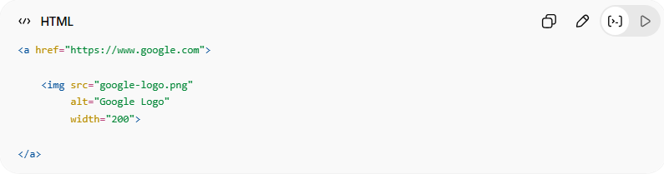
<a href="https://www.google.com">

<img src="google-logo.png"
alt="Google Logo"
width="200">

</a>
👉 Clicking the image opens the link

9. 🔘 Use Button as a Link
# Source: AI Source: Provided by: [Data Path: Persons Table -> ID Column: 1, Name_En Column: Motasem Essam] -> From: [ChatGPT] on [5/6/2026]
📖 Description
You can use a button to navigate to another page using JavaScript.
💻 Example:
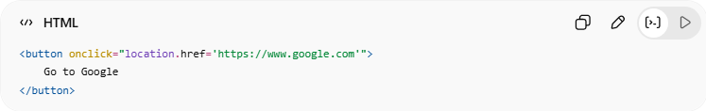
<button onclick="location.href='https://www.google.com'">
Go to Google
</button>
👉 Clicking the button opens the webpage

💻 Example

Full Example
# Source: AI Source: Provided by: [Data Path: Persons Table -> ID Column: 1, Name_En Column: Motasem Essam] -> From: [ChatGPT] on [5/6/2026]
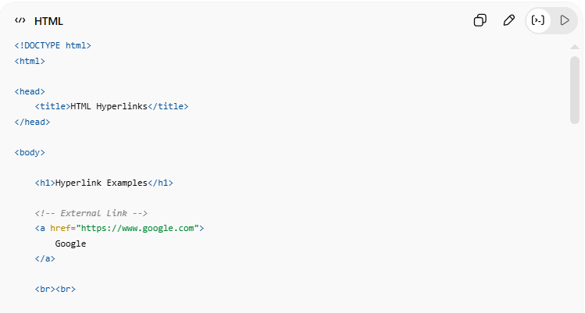
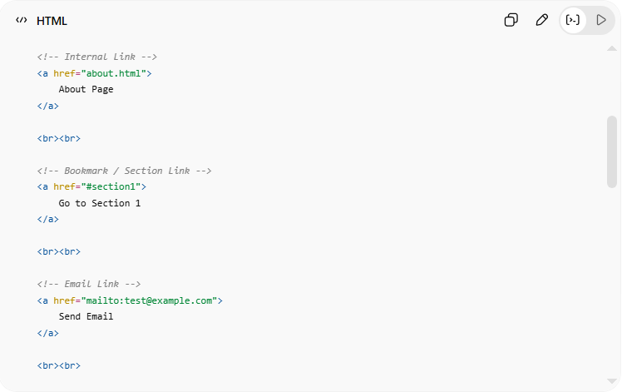
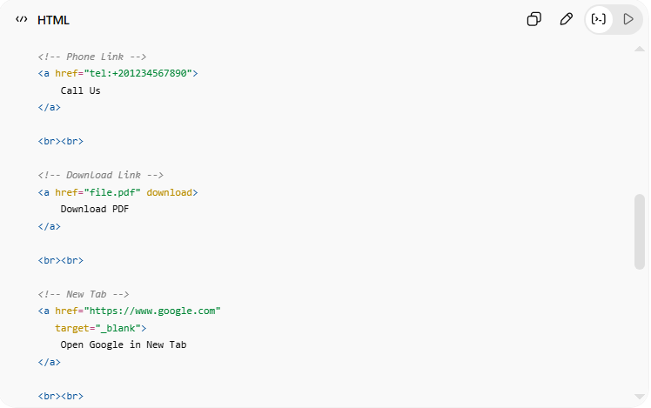
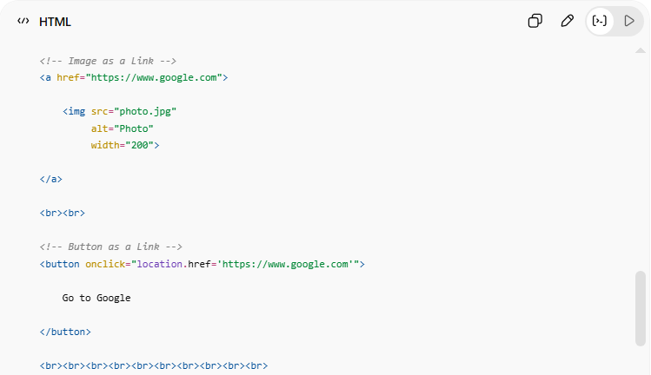
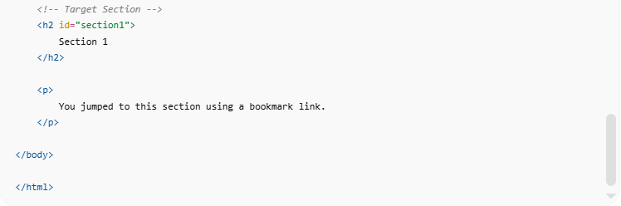
<!DOCTYPE html>
<html>

<head>
<title>HTML Hyperlinks</title>
</head>

<body>

<h1>Hyperlink Examples</h1>

<!-- External Link -->
<a href="https://www.google.com">
Google
</a>

<br><br>

<!-- Internal Link -->
<a href="about.html">
About Page
</a>

<br><br>

<!-- Bookmark / Section Link -->
<a href="#section1">
Go to Section 1
</a>

<br><br>

<!-- Email Link -->
<a href="mailto:test@example.com">
Send Email
</a>

<br><br>

<!-- Phone Link -->
<a href="tel:+201234567890">
Call Us
</a>

<br><br>

<!-- Download Link -->
<a href="file.pdf" download>
Download PDF
</a>

<br><br>

<!-- New Tab -->
<a href="https://www.google.com"
target="_blank">
Open Google in New Tab
</a>

<br><br>

<!-- Image as a Link -->
<a href="https://www.google.com">

<img src="photo.jpg"
alt="Photo"
width="200">

</a>

<br><br>

<!-- Button as a Link -->
<button onclick="location.href='https://www.google.com'">

Go to Google

</button>

<br><br><br><br><br><br><br><br><br><br>

<!-- Target Section -->
<h2 id="section1">
Section 1
</h2>

<p>
You jumped to this section using a bookmark link.
</p>

</body>

</html>

Real Example
# Source: ScreenShot Source: Provided by: [Persons Table -> ID Column: 1, Name_En Column: Motasem Essam] -> Tool: [Automation Table -> ID Column: 16, Name_En Column: Screen Capture] -> From [Operating System: Windows] on [5/6/2026]
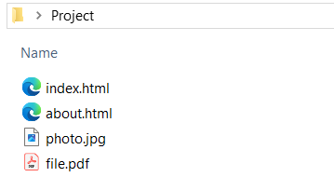

Index.html
# Source: ScreenShot Source: Provided by: [Persons Table -> ID Column: 1, Name_En Column: Motasem Essam] -> Tool: [Automation Table -> ID Column: 16, Name_En Column: Screen Capture] -> From [Operating System: Windows] on [5/6/2026]
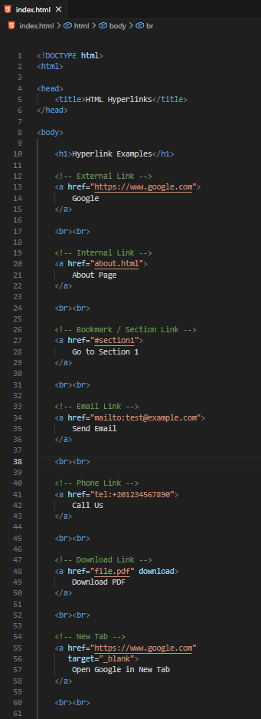
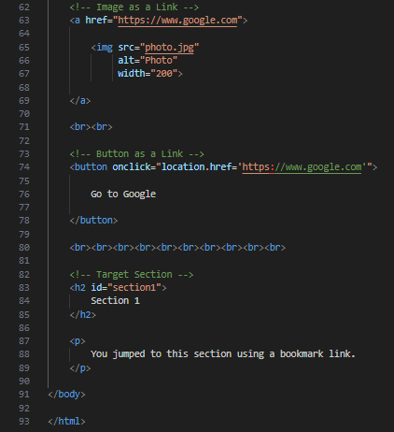
<!DOCTYPE html>
<html>

<head>
<title>HTML Hyperlinks</title>
</head>

<body>

<h1>Hyperlink Examples</h1>

<!-- External Link -->
<a href="https://www.google.com">
Google
</a>

<br><br>

<!-- Internal Link -->
<a href="about.html">
About Page
</a>

<br><br>

<!-- Bookmark / Section Link -->
<a href="#section1">
Go to Section 1
</a>

<br><br>

<!-- Email Link -->
<a href="mailto:test@example.com">
Send Email
</a>

<br><br>

<!-- Phone Link -->
<a href="tel:+201234567890">
Call Us
</a>

<br><br>

<!-- Download Link -->
<a href="file.pdf" download>
Download PDF
</a>

<br><br>

<!-- New Tab -->
<a href="https://www.google.com"
target="_blank">
Open Google in New Tab
</a>

<br><br>

<!-- Image as a Link -->
<a href="https://www.google.com">

<img src="photo.jpg"
alt="Photo"
width="200">

</a>

<br><br>

<!-- Button as a Link -->
<button onclick="location.href='https://www.google.com'">

Go to Google

</button>

<br><br><br><br><br><br><br><br><br><br>

<!-- Target Section -->
<h2 id="section1">
Section 1
</h2>

<p>
You jumped to this section using a bookmark link.
</p>

</body>

</html>

about.html
# Source: ScreenShot Source: Provided by: [Persons Table -> ID Column: 1, Name_En Column: Motasem Essam] -> Tool: [Automation Table -> ID Column: 16, Name_En Column: Screen Capture] -> From [Operating System: Windows] on [5/6/2026]
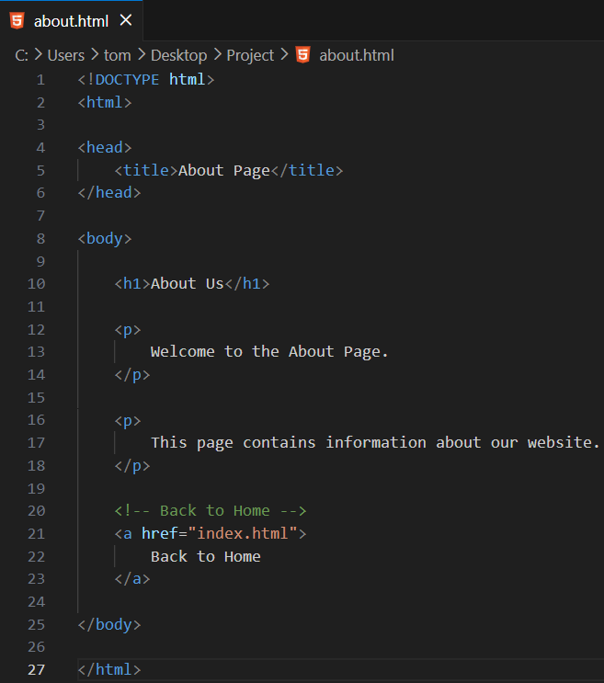
<!DOCTYPE html>
<html>

<head>
<title>About Page</title>
</head>

<body>

<h1>About Us</h1>

<p>
Welcome to the About Page.
</p>

<p>
This page contains information about our website.
</p>

<!-- Back to Home -->
<a href="index.html">
Back to Home
</a>

</body>

</html>

Run
# Source: GIF Source: Provided by: [Persons Table -> ID Column: 1, Name_En Column: Motasem Essam] -> Tool: [Automation Table -> ID Column: 17, Name_En Column: GIF Recorder] -> From [Operating System: Windows] on [5/6/2026]


🎯 target Attribute

📘 Definition
# Source: AI Source: Provided by: [Data Path: Persons Table -> ID Column: 1, Name_En Column: Motasem Essam] -> From: [ChatGPT] on [5/6/2026]
The target attribute specifies where the linked document will open.
It is commonly used with the HTML <a> element.

🔤 Common target Values
# Source: AI Source: Provided by: [Data Path: Persons Table -> ID Column: 1, Name_En Column: Motasem Essam] -> From: [ChatGPT] on [5/6/2026]
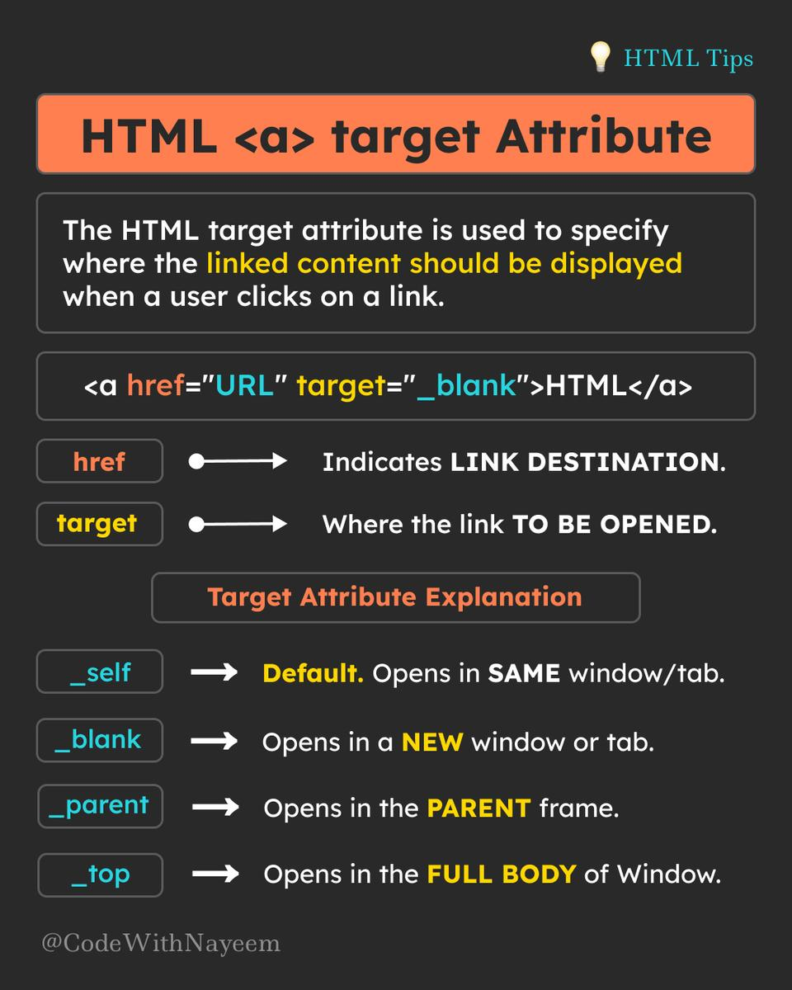
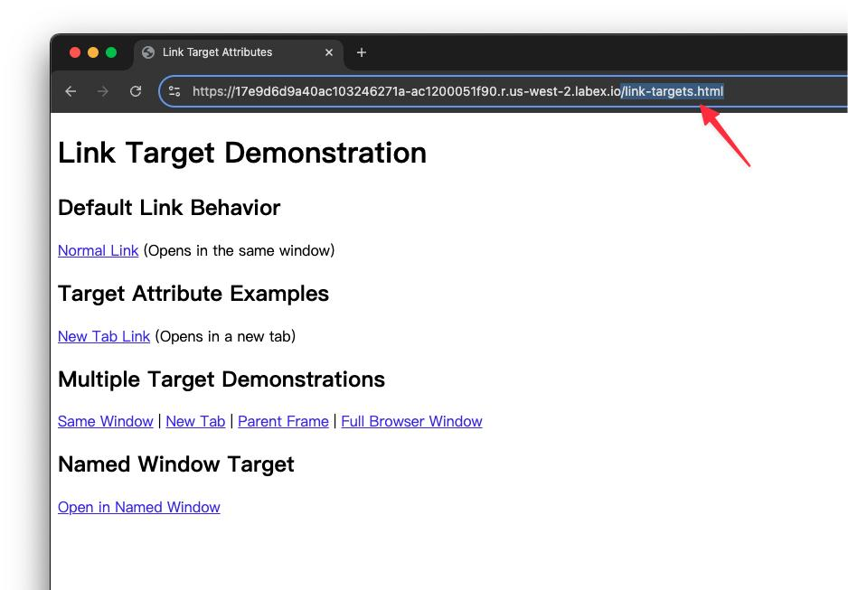
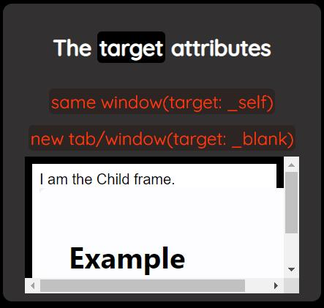

1. _self (Default)
# Source: AI Source: Provided by: [Data Path: Persons Table -> ID Column: 1, Name_En Column: Motasem Essam] -> From: [ChatGPT] on [5/6/2026]
📖 Description
Opens the link in the same tab/window.
💻 Example:
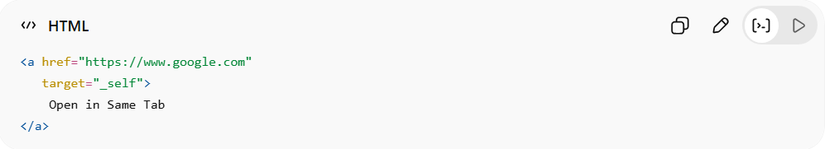
<a href="https://www.google.com"
target="_self">
Open in Same Tab
</a>
👉 Default behavior

2. _blank
# Source: AI Source: Provided by: [Data Path: Persons Table -> ID Column: 1, Name_En Column: Motasem Essam] -> From: [ChatGPT] on [5/6/2026]
📖 Description
Opens the link in a new tab/window.
💻 Example:
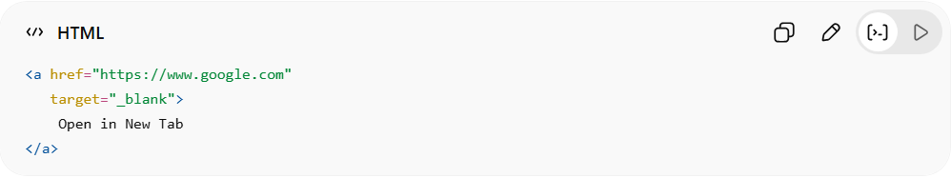
<a href="https://www.google.com"
target="_blank">
Open in New Tab
</a>
👉 Most commonly used target value

3. _parent
# Source: AI Source: Provided by: [Data Path: Persons Table -> ID Column: 1, Name_En Column: Motasem Essam] -> From: [ChatGPT] on [5/6/2026]
📖 Description
Opens the link in the parent frame.
💻 Example:
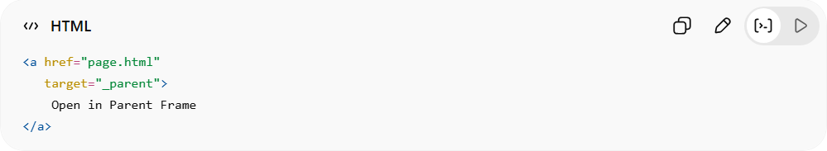
<a href="page.html"
target="_parent">
Open in Parent Frame
</a>
👉 Used with frames/iframes

4. _top
# Source: AI Source: Provided by: [Data Path: Persons Table -> ID Column: 1, Name_En Column: Motasem Essam] -> From: [ChatGPT] on [5/6/2026]
📖 Description
Opens the link in the full browser window, removing all frames.
💻 Example:
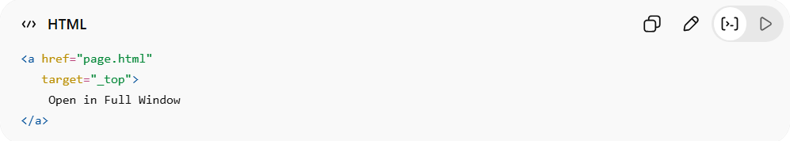
<a href="page.html"
target="_top">
Open in Full Window
</a>
👉 Useful in framed layouts

5. 🎯 Custom Frame Name
# Source: AI Source: Provided by: [Data Path: Persons Table -> ID Column: 1, Name_En Column: Motasem Essam] -> From: [ChatGPT] on [5/6/2026]
📖 Description
Opens the link inside a specific iframe/frame.
💻 Example:
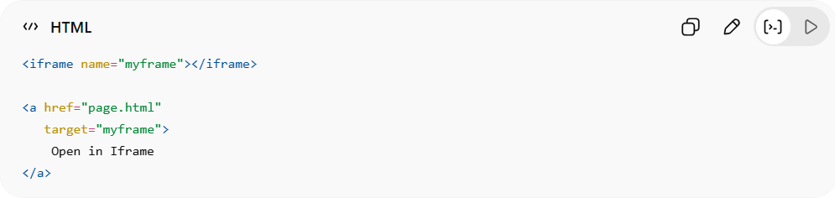
<iframe name="myframe"></iframe>
<a href="page.html"
target="myframe">
Open in Iframe
</a>
👉 Targets a named iframe

⚖️ Target Values Comparison
# Source: AI Source: Provided by: [Data Path: Persons Table -> ID Column: 1, Name_En Column: Motasem Essam] -> From: [ChatGPT] on [5/6/2026]
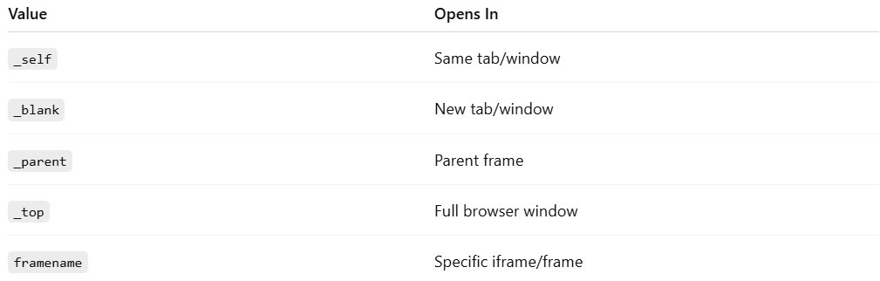
Value | Opens In
_self | Same tab/window
_blank | New tab/window
_parent | Parent frame
_top | Full browser window
framename | Specific iframe/frame

💻 Example

Full Example
# Source: AI Source: Provided by: [Data Path: Persons Table -> ID Column: 1, Name_En Column: Motasem Essam] -> From: [ChatGPT] on [5/6/2026]
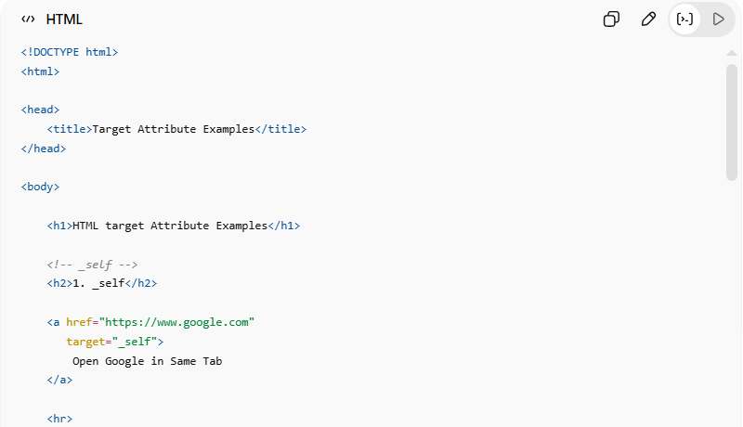
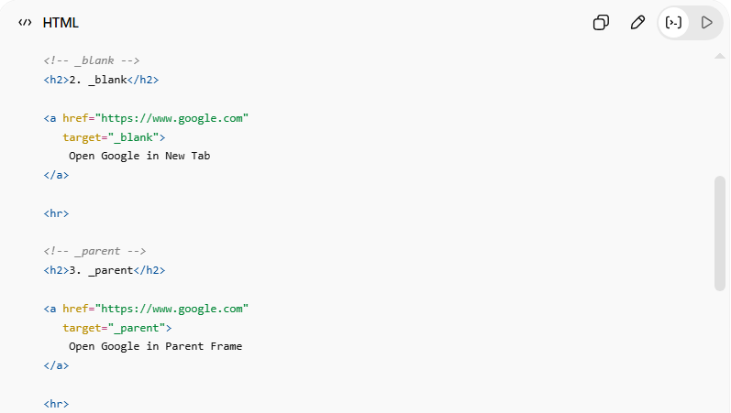
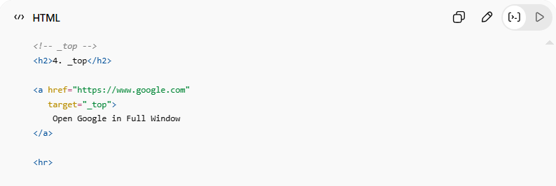
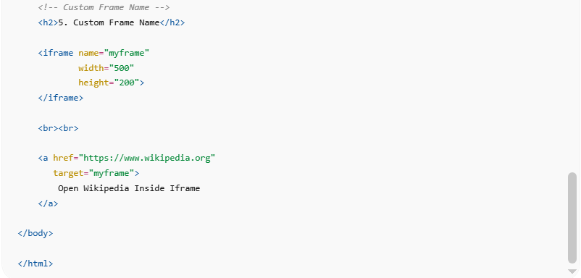
<!DOCTYPE html>
<html>

<head>
<title>Target Attribute Examples</title>
</head>

<body>

<h1>HTML target Attribute Examples</h1>

<!-- _self -->
<h2>1. _self</h2>

<a href="https://www.google.com"
target="_self">
Open Google in Same Tab
</a>

<hr>

<!-- _blank -->
<h2>2. _blank</h2>

<a href="https://www.google.com"
target="_blank">
Open Google in New Tab
</a>

<hr>

<!-- _parent -->
<h2>3. _parent</h2>

<a href="https://www.google.com"
target="_parent">
Open Google in Parent Frame
</a>

<hr>

<!-- _top -->
<h2>4. _top</h2>

<a href="https://www.google.com"
target="_top">
Open Google in Full Window
</a>

<hr>

<!-- Custom Frame Name -->
<h2>5. Custom Frame Name</h2>

<iframe name="myframe"
width="500"
height="200">
</iframe>

<br><br>

<a href="https://www.wikipedia.org"
target="myframe">
Open Wikipedia Inside Iframe
</a>

</body>

</html>

Real Example
# Source: ScreenShot Source: Provided by: [Persons Table -> ID Column: 1, Name_En Column: Motasem Essam] -> Tool: [Automation Table -> ID Column: 16, Name_En Column: Screen Capture] -> From [Operating System: Windows] on [5/6/2026]
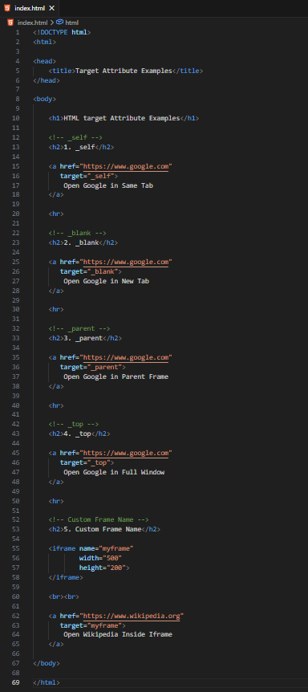
<!DOCTYPE html>
<html>

<head>
<title>Target Attribute Examples</title>
</head>

<body>

<h1>HTML target Attribute Examples</h1>

<!-- _self -->
<h2>1. _self</h2>

<a href="https://www.google.com"
target="_self">
Open Google in Same Tab
</a>

<hr>

<!-- _blank -->
<h2>2. _blank</h2>

<a href="https://www.google.com"
target="_blank">
Open Google in New Tab
</a>

<hr>

<!-- _parent -->
<h2>3. _parent</h2>

<a href="https://www.google.com"
target="_parent">
Open Google in Parent Frame
</a>

<hr>

<!-- _top -->
<h2>4. _top</h2>

<a href="https://www.google.com"
target="_top">
Open Google in Full Window
</a>

<hr>

<!-- Custom Frame Name -->
<h2>5. Custom Frame Name</h2>

<iframe name="myframe"
width="500"
height="200">
</iframe>

<br><br>

<a href="https://www.wikipedia.org"
target="myframe">
Open Wikipedia Inside Iframe
</a>

</body>

</html>


⚠️ Best Practice
# Source: AI Source: Provided by: [Data Path: Persons Table -> ID Column: 1, Name_En Column: Motasem Essam] -> From: [ChatGPT] on [5/6/2026]
✅ Security Recommendation for _blank
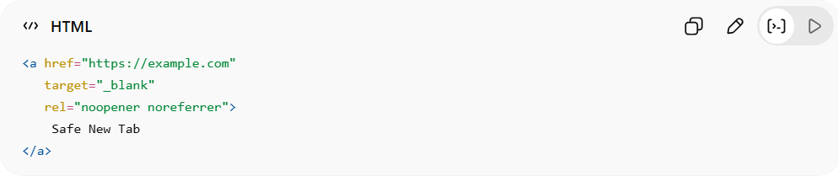
<a href="https://example.com"
target="_blank"
rel="noopener noreferrer">
Safe New Tab
</a>
👉 Prevents security/privacy issues

🚀 In short:
# Source: AI Source: Provided by: [Data Path: Persons Table -> ID Column: 1, Name_En Column: Motasem Essam] -> From: [ChatGPT] on [5/6/2026]
The target attribute controls where hyperlinks open, such as the same tab, new tab, parent frame, or iframe.

🏷️ Hyperlink with title Attribute

📖 Description
# Source: AI Source: Provided by: [Data Path: Persons Table -> ID Column: 1, Name_En Column: Motasem Essam] -> From: [ChatGPT] on [5/6/2026]
The title attribute adds extra information to a hyperlink.
👉 When the user hovers over the link, a tooltip appears.

💻 Simple Example
# Source: AI Source: Provided by: [Data Path: Persons Table -> ID Column: 1, Name_En Column: Motasem Essam] -> From: [ChatGPT] on [5/6/2026]
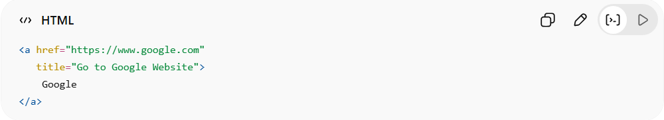
<a href="https://www.google.com"
title="Go to Google Website">
Google
</a>

💻 Example

Full Example
# Source: AI Source: Provided by: [Data Path: Persons Table -> ID Column: 1, Name_En Column: Motasem Essam] -> From: [ChatGPT] on [5/6/2026]
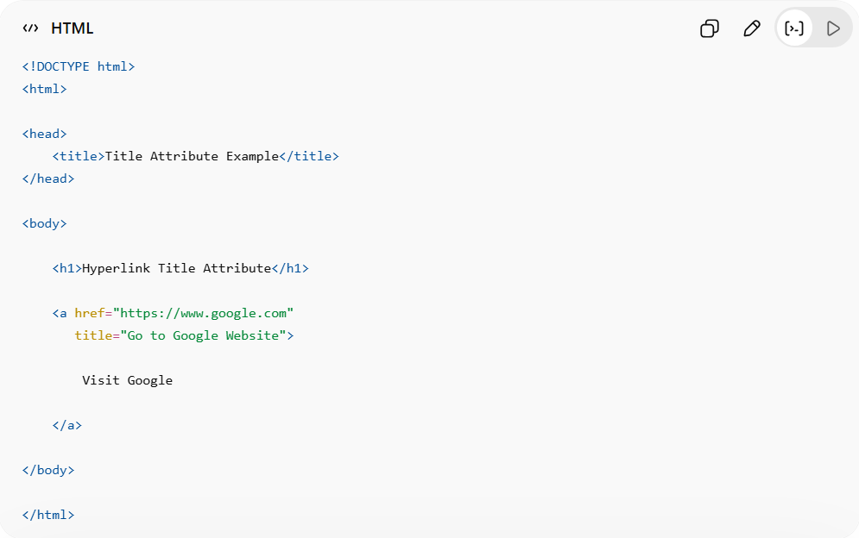
<!DOCTYPE html>
<html>
<head>
<title>Title Attribute Example</title>
</head>
<body>
<h1>Hyperlink Title Attribute</h1>
<a href="https://www.google.com"
title="Go to Google Website">
Visit Google
</a>
</body>
</html>

Real Example
# Source: ScreenShot Source: Provided by: [Persons Table -> ID Column: 1, Name_En Column: Motasem Essam] -> Tool: [Automation Table -> ID Column: 16, Name_En Column: Screen Capture] -> From [Operating System: Windows] on [5/6/2026]
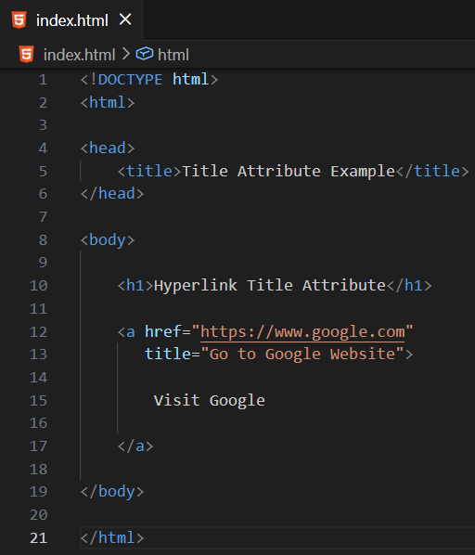
<!DOCTYPE html>
<html>

<head>
<title>Title Attribute Example</title>
</head>

<body>

<h1>Hyperlink Title Attribute</h1>

<a href="https://www.google.com"
title="Go to Google Website">

Visit Google

</a>

</body>

</html>


👀 What Happens?
# Source: AI Source: Provided by: [Data Path: Persons Table -> ID Column: 1, Name_En Column: Motasem Essam] -> From: [ChatGPT] on [5/6/2026]
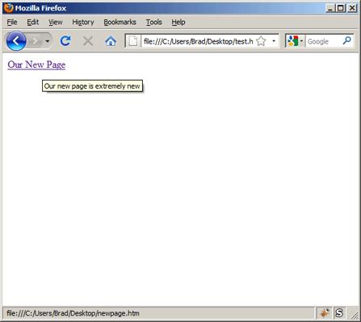
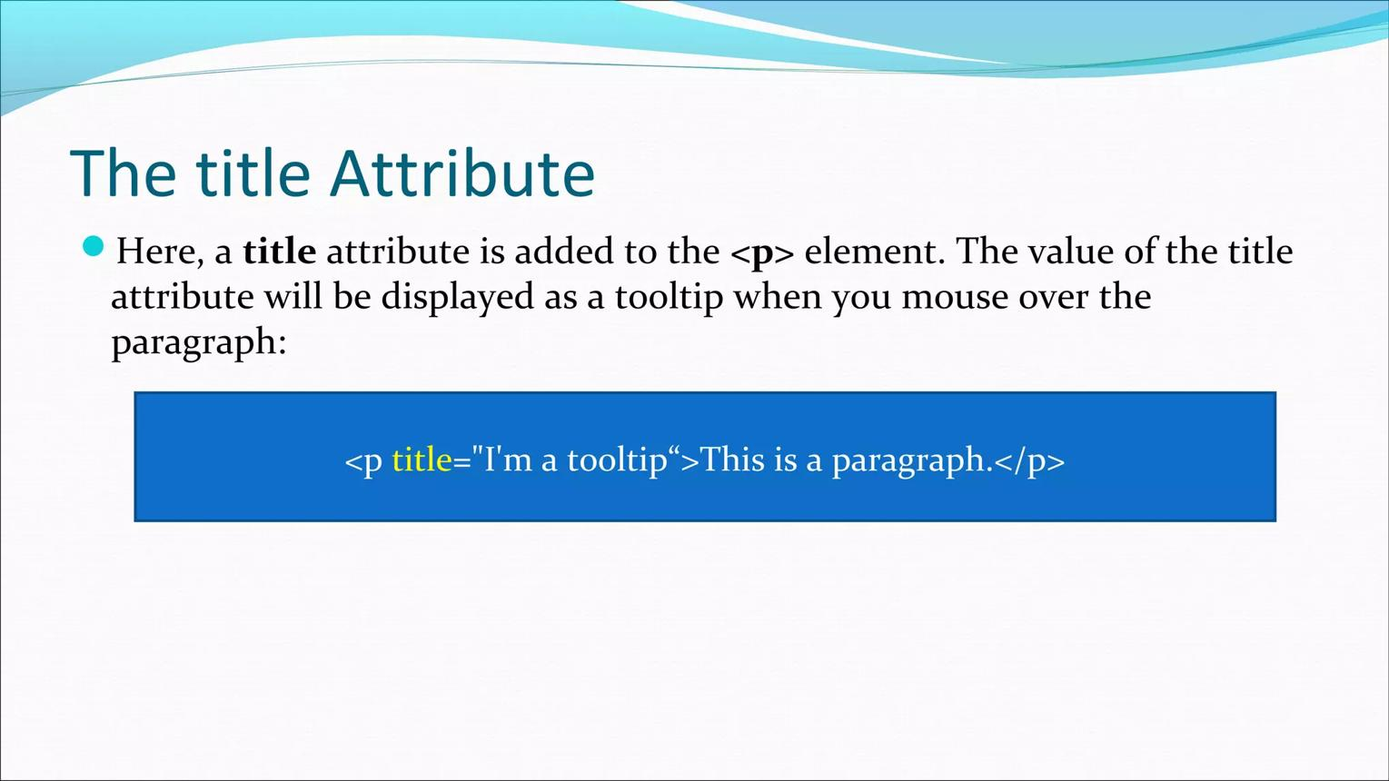
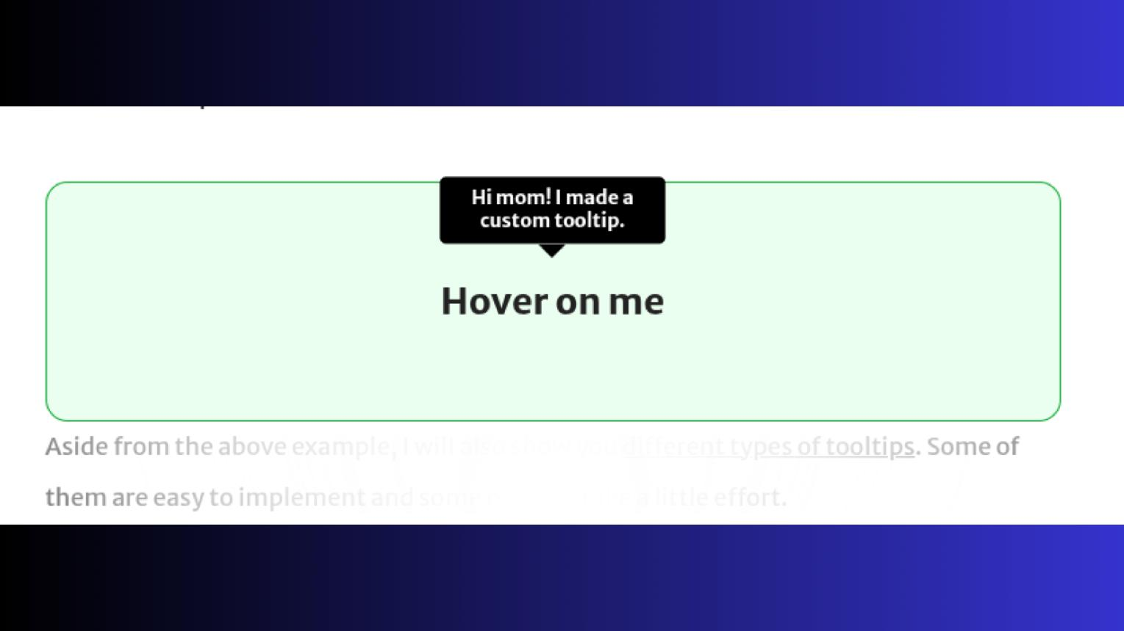
👉 When the mouse hovers over the link, the browser shows:
Go to Google Website
as a small tooltip.

🚀 Best Practice
# Source: AI Source: Provided by: [Data Path: Persons Table -> ID Column: 1, Name_En Column: Motasem Essam] -> From: [ChatGPT] on [5/6/2026]
✅ Use title to provide helpful extra information
❌ Do not make titles too long or unnecessary

🎨 Styling Hyperlinks

1. 🌈 HTML Link Colors

📖 Description
# Source: AI Source: Provided by: [Data Path: Persons Table -> ID Column: 1, Name_En Column: Motasem Essam] -> From: [ChatGPT] on [5/6/2026]
You can change hyperlink colors using CSS.
Different link states can have different colors:
- normal link
- visited link
- hover
- active

🔤 Link States
# Source: AI Source: Provided by: [Data Path: Persons Table -> ID Column: 1, Name_En Column: Motasem Essam] -> From: [ChatGPT] on [5/6/2026]
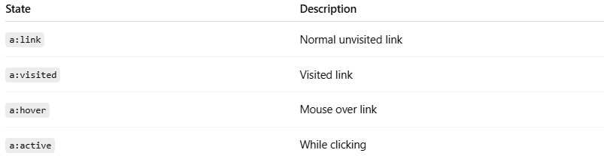
State | Description
a:link | Normal unvisited link
a:visited | Visited link
a:hover | Mouse over link
a:active | While clicking

💻 Example

Full Example
# Source: AI Source: Provided by: [Data Path: Persons Table -> ID Column: 1, Name_En Column: Motasem Essam] -> From: [ChatGPT] on [5/6/2026]
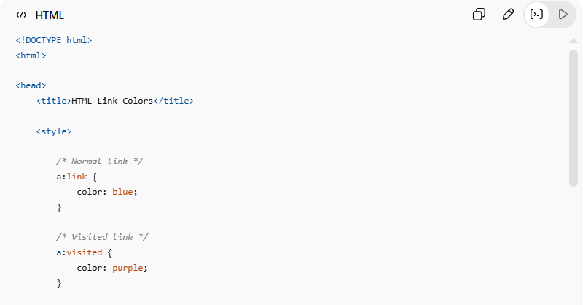
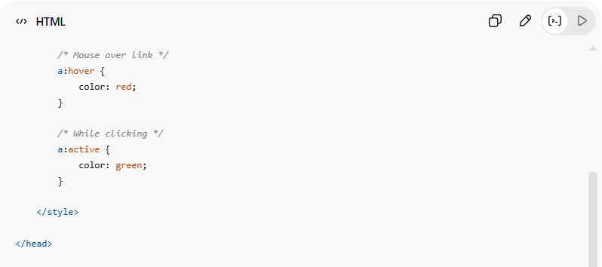
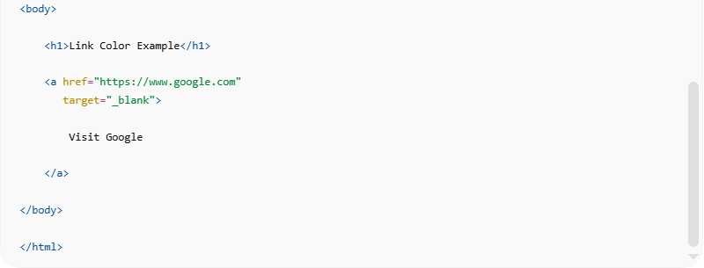
<!DOCTYPE html>
<html>

<head>
<title>HTML Link Colors</title>

<style>

/* Normal link */
a:link {
color: blue;
}

/* Visited link */
a:visited {
color: purple;
}

/* Mouse over link */
a:hover {
color: red;
}

/* While clicking */
a:active {
color: green;
}

</style>

</head>

<body>

<h1>Link Color Example</h1>

<a href="https://www.google.com"
target="_blank">

Visit Google

</a>

</body>

</html>

Real Example
# Source: ScreenShot Source: Provided by: [Persons Table -> ID Column: 1, Name_En Column: Motasem Essam] -> Tool: [Automation Table -> ID Column: 16, Name_En Column: Screen Capture] -> From [Operating System: Windows] on [5/6/2026]
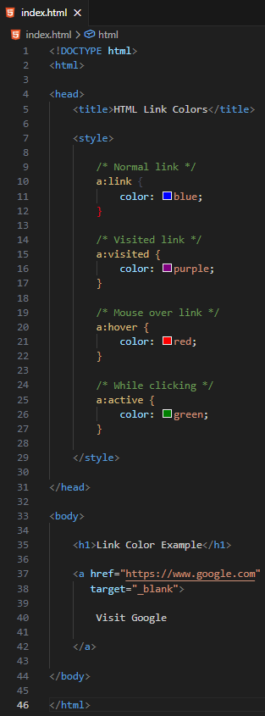
<!DOCTYPE html>
<html>

<head>
<title>HTML Link Colors</title>

<style>

/* Normal link */
a:link {
color: blue;
}

/* Visited link */
a:visited {
color: purple;
}

/* Mouse over link */
a:hover {
color: red;
}

/* While clicking */
a:active {
color: green;
}

</style>

</head>

<body>

<h1>Link Color Example</h1>

<a href="https://www.google.com"
target="_blank">

Visit Google

</a>

</body>

</html>


🧪 What You Can Test
# Source: AI Source: Provided by: [Data Path: Persons Table -> ID Column: 1, Name_En Column: Motasem Essam] -> From: [ChatGPT] on [5/6/2026]
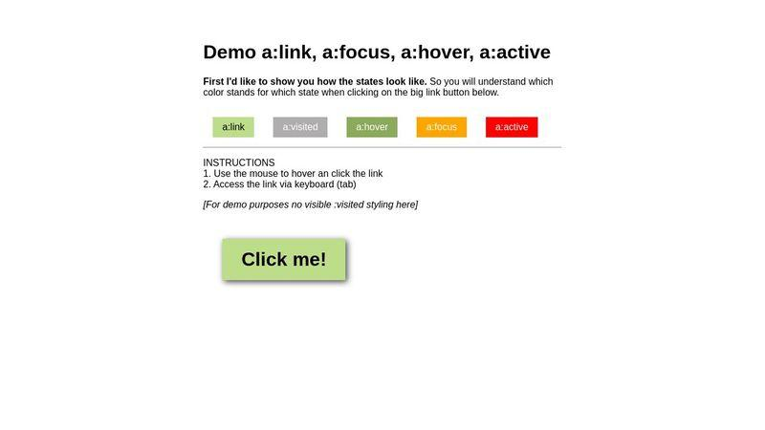
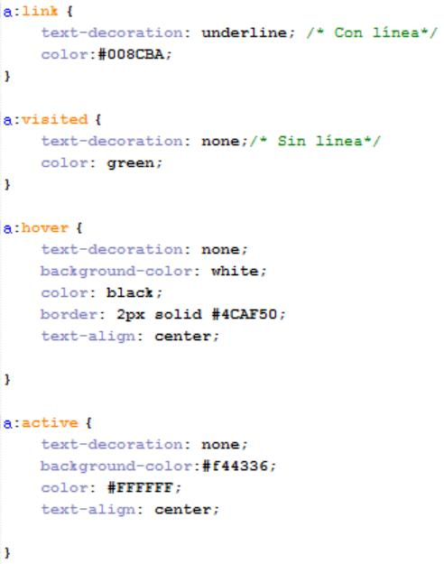
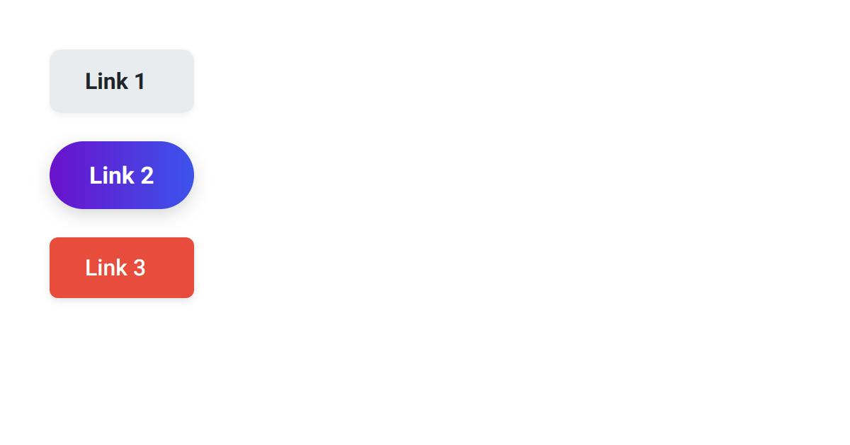
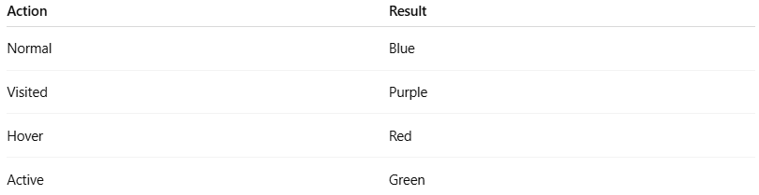
Action | Result
Normal | Blue
Visited | Purple
Hover | Red
Active | Green

2. 🔘 Link Buttons

📖 Description
# Source: AI Source: Provided by: [Data Path: Persons Table -> ID Column: 1, Name_En Column: Motasem Essam] -> From: [ChatGPT] on [5/6/2026]
You can style an HTML link (<a>) to look like a button using CSS.

💻 Example

Full Example
# Source: AI Source: Provided by: [Data Path: Persons Table -> ID Column: 1, Name_En Column: Motasem Essam] -> From: [ChatGPT] on [5/6/2026]
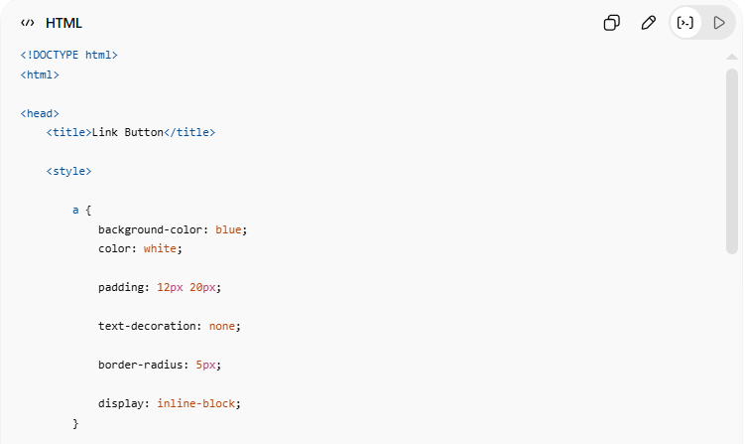
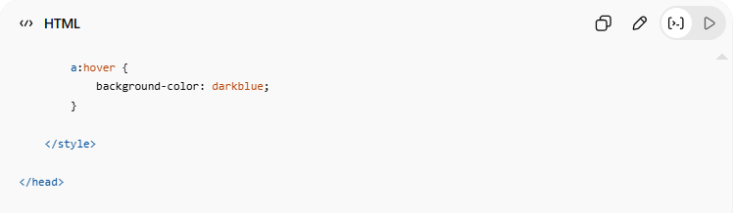
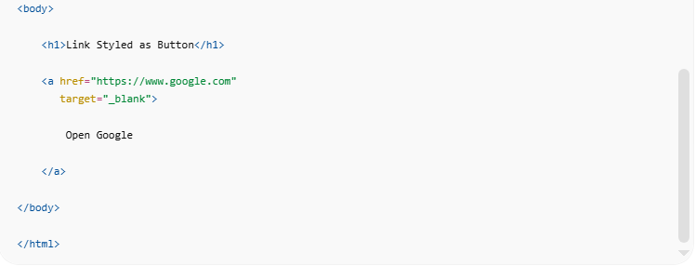
<!DOCTYPE html>
<html>

<head>
<title>Link Button</title>

<style>

a {
background-color: blue;
color: white;

padding: 12px 20px;

text-decoration: none;

border-radius: 5px;

display: inline-block;
}

a:hover {
background-color: darkblue;
}

</style>

</head>

<body>

<h1>Link Styled as Button</h1>

<a href="https://www.google.com"
target="_blank">

Open Google

</a>

</body>

</html>

Real Example
# Source: ScreenShot Source: Provided by: [Persons Table -> ID Column: 1, Name_En Column: Motasem Essam] -> Tool: [Automation Table -> ID Column: 16, Name_En Column: Screen Capture] -> From [Operating System: Windows] on [5/6/2026]
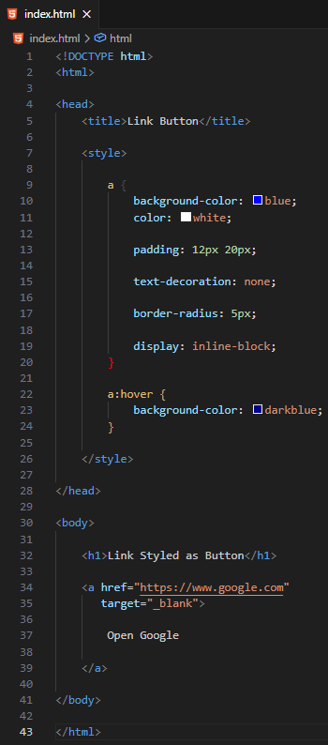
<!DOCTYPE html>
<html>

<head>
<title>Link Button</title>

<style>

a {
background-color: blue;
color: white;

padding: 12px 20px;

text-decoration: none;

border-radius: 5px;

display: inline-block;
}

a:hover {
background-color: darkblue;
}

</style>

</head>

<body>

<h1>Link Styled as Button</h1>

<a href="https://www.google.com"
target="_blank">

Open Google

</a>

</body>

</html>


🧪 What You Can Test
# Source: AI Source: Provided by: [Data Path: Persons Table -> ID Column: 1, Name_En Column: Motasem Essam] -> From: [ChatGPT] on [5/6/2026]
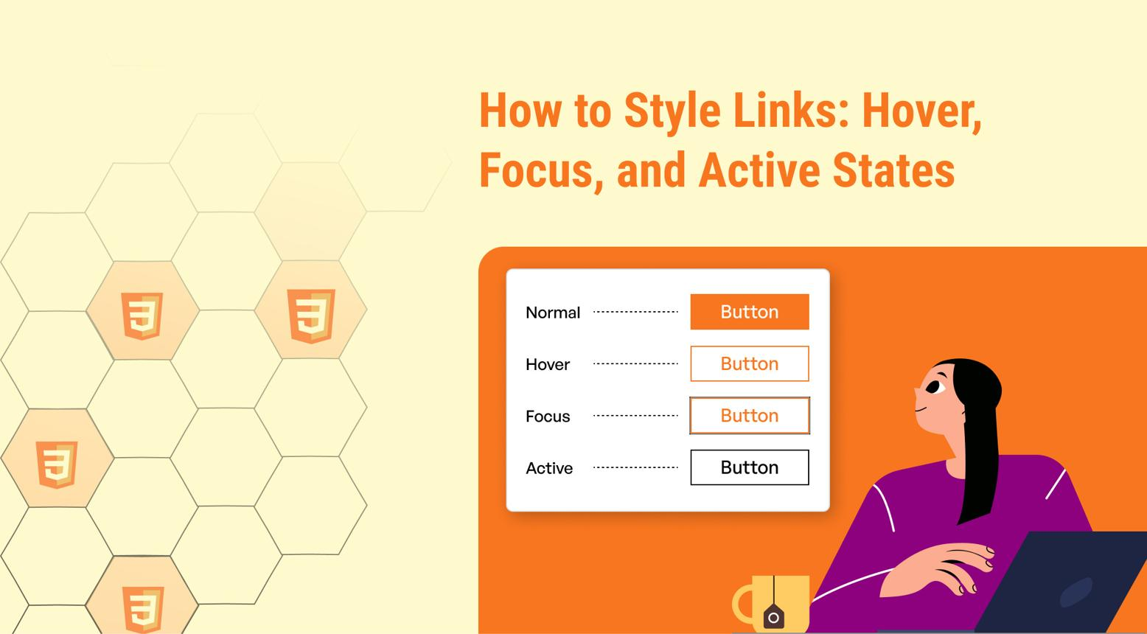
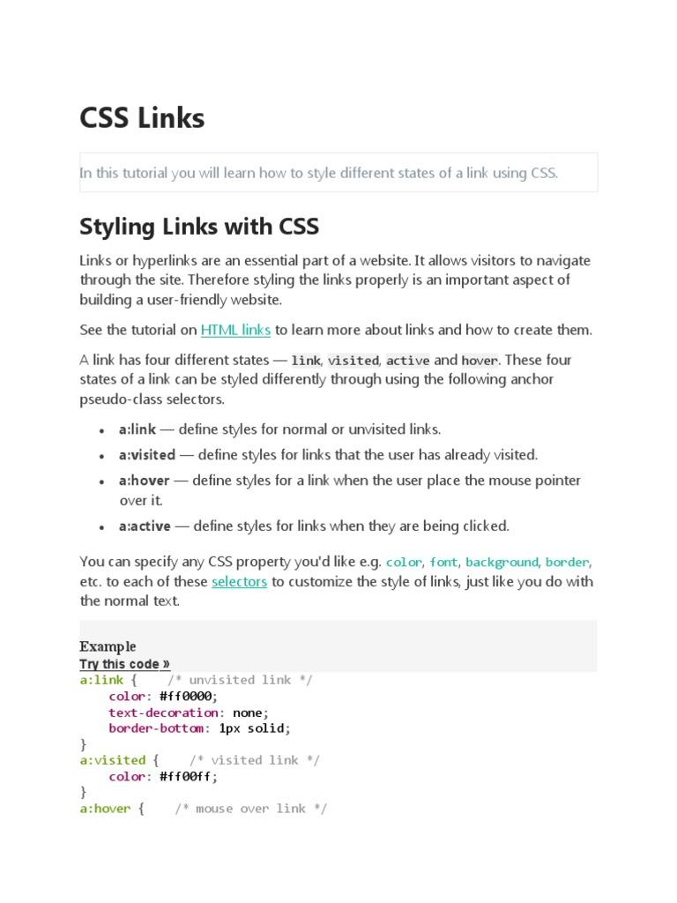
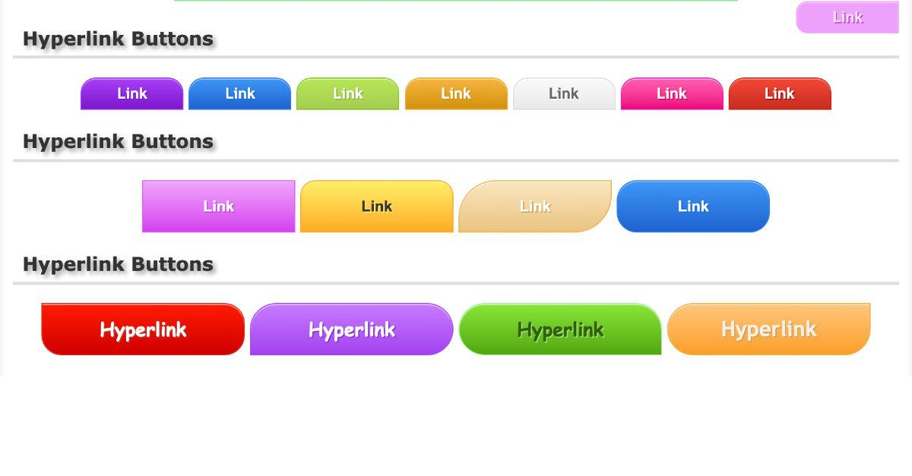
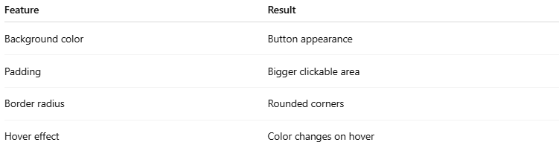
Feature | Result
Background color | Button appearance
Padding | Bigger clickable area
Border radius | Rounded corners
Hover effect | Color changes on hover

⚠️ Important Notes

✅ href is the main attribute
# Source: AI Source: Provided by: [Data Path: Persons Table -> ID Column: 1, Name_En Column: Motasem Essam] -> From: [ChatGPT] on [5/6/2026]
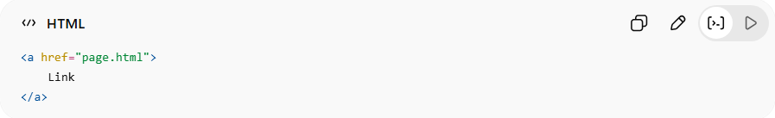
<a href="page.html">
Link
</a>
👉 Defines link destination

✅ <a> is an inline element
# Source: AI Source: Provided by: [Data Path: Persons Table -> ID Column: 1, Name_En Column: Motasem Essam] -> From: [ChatGPT] on [5/6/2026]
👉 Can appear inside text

❌ Avoid empty links
# Source: AI Source: Provided by: [Data Path: Persons Table -> ID Column: 1, Name_En Column: Motasem Essam] -> From: [ChatGPT] on [5/6/2026]
❌ Bad:
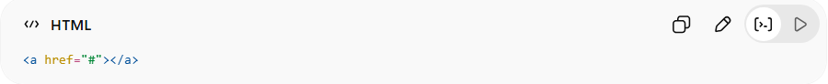
<a href="#"></a>

✅ Better:
# Source: AI Source: Provided by: [Data Path: Persons Table -> ID Column: 1, Name_En Column: Motasem Essam] -> From: [ChatGPT] on [5/6/2026]
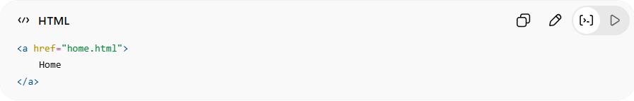
<a href="home.html">
Home
</a>

🚀 In short:
# Source: AI Source: Provided by: [Data Path: Persons Table -> ID Column: 1, Name_En Column: Motasem Essam] -> From: [ChatGPT] on [5/6/2026]
The HTML <a> element creates hyperlinks that connect webpages, files, emails, phone numbers, and sections together.

